**Extract Transform Load (ETL) Using Pentaho Data Integration:**

DIM_AGENTS

In order to successfully load type 1-dimension, DIM_AGENTS, we followed the steps below:

1)We first imported the file by using the CSV file input.

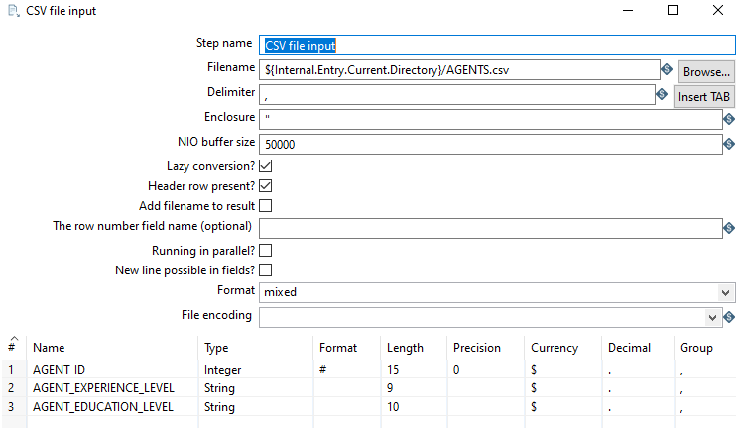

As there is no need for any data transformation, Table Output was used to load data into the target DIM_AGENTS table.

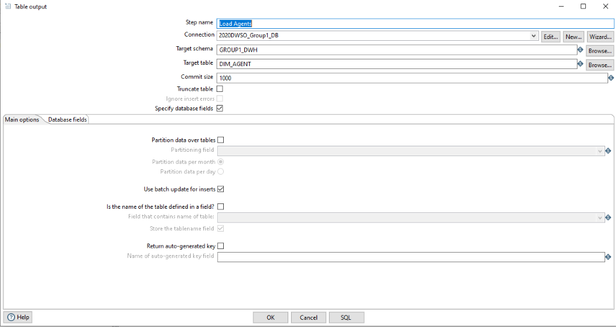

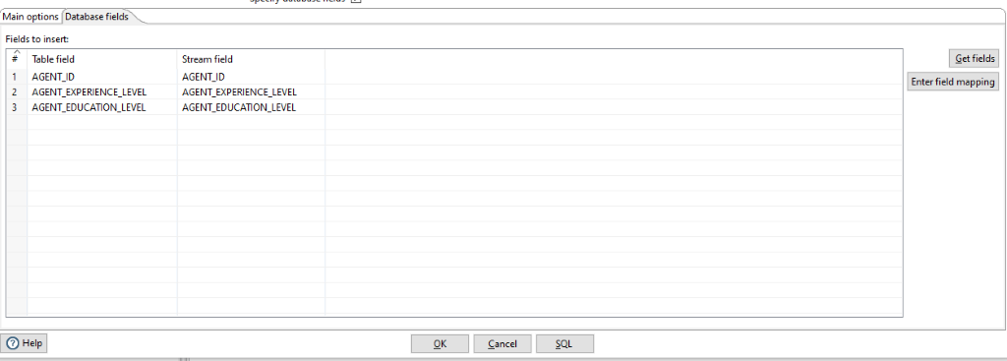

DIM_CHANNELS:

Step1: We first access the Source table in IST346 dbo schema by using Input Table:

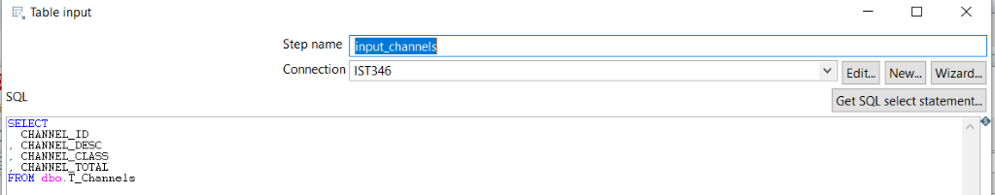

Step2: Then we use Table Output to load data in our target table in 2020DWSO_GROUP1_DWH

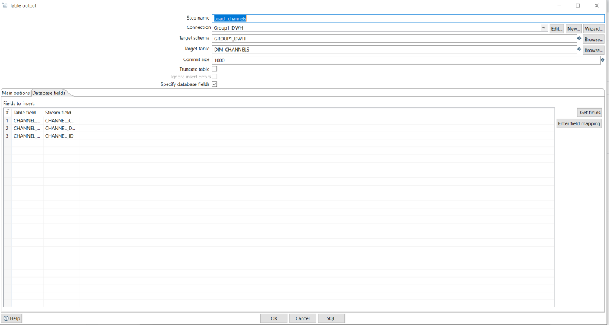

DIM_PRODUCTS:

Step1: We followed the same steps as described in the previous transformation

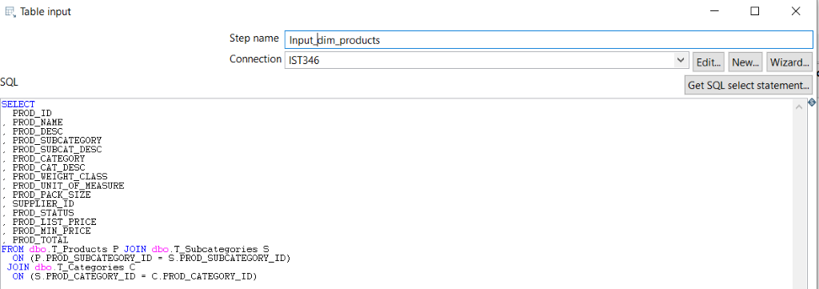

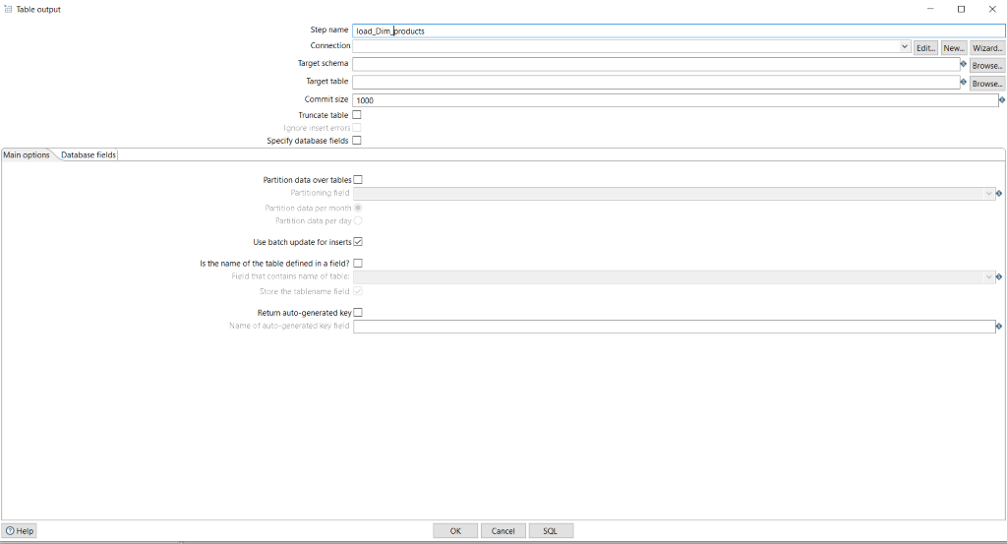

DIM_CUSTOMERS:

The ETL process method used is type 2 dimension as shown in the step below:

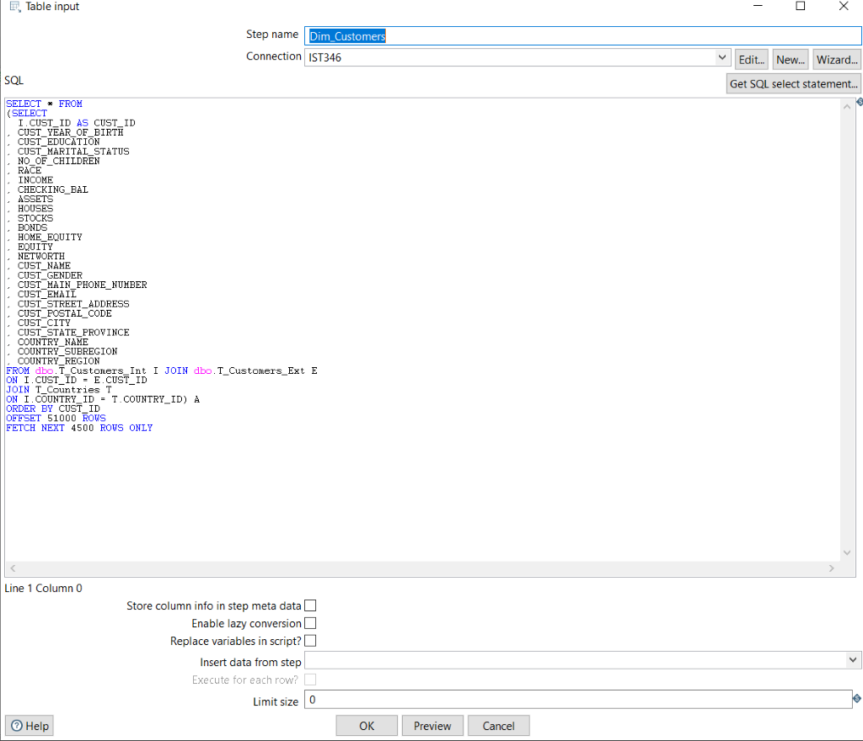

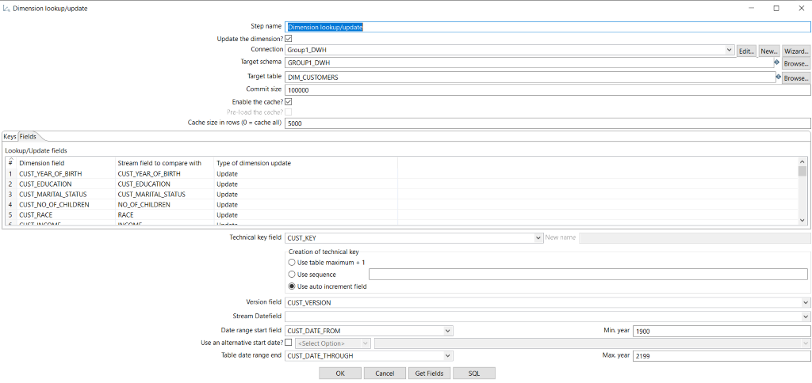

Then, we updated DIM_CUSTOMERS by loading additional data from the csv input file “CUSTOMERS_ADJ.CSV”:

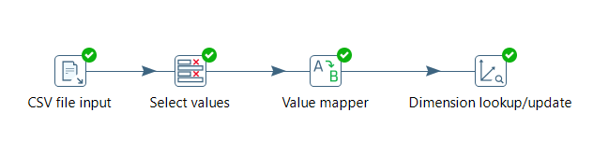

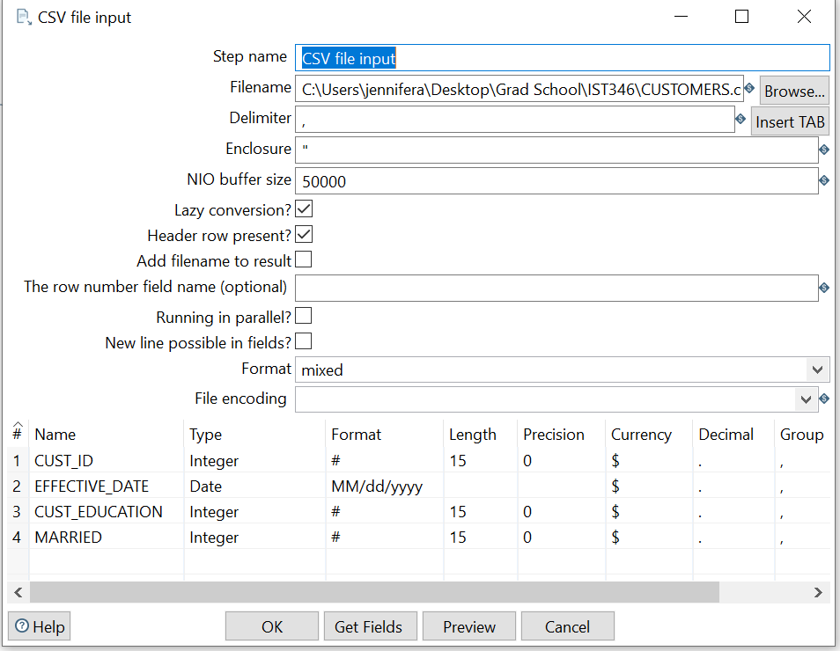

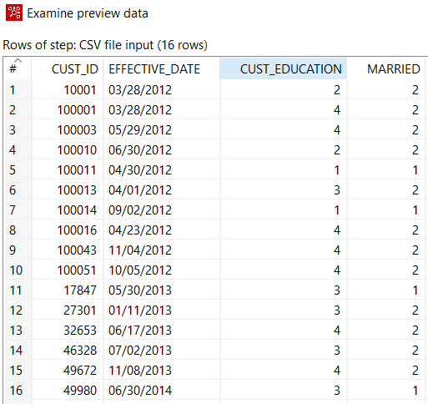

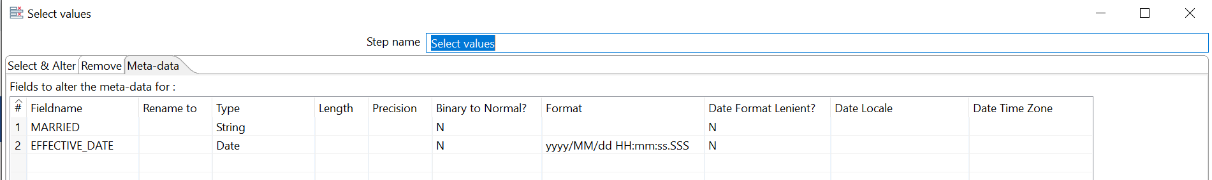

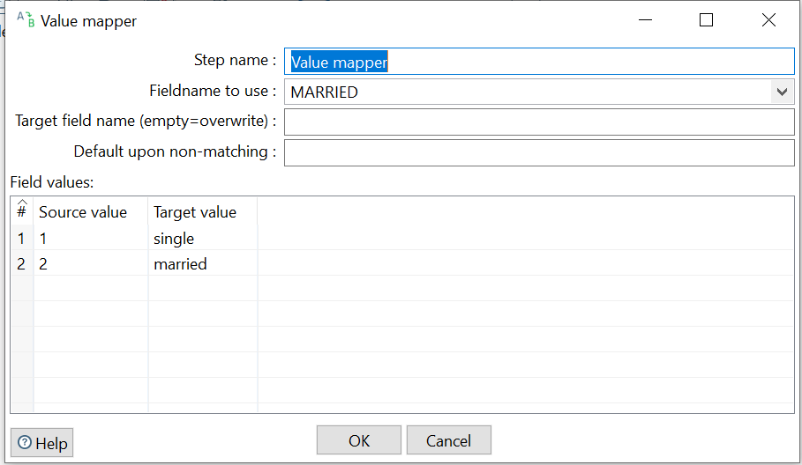

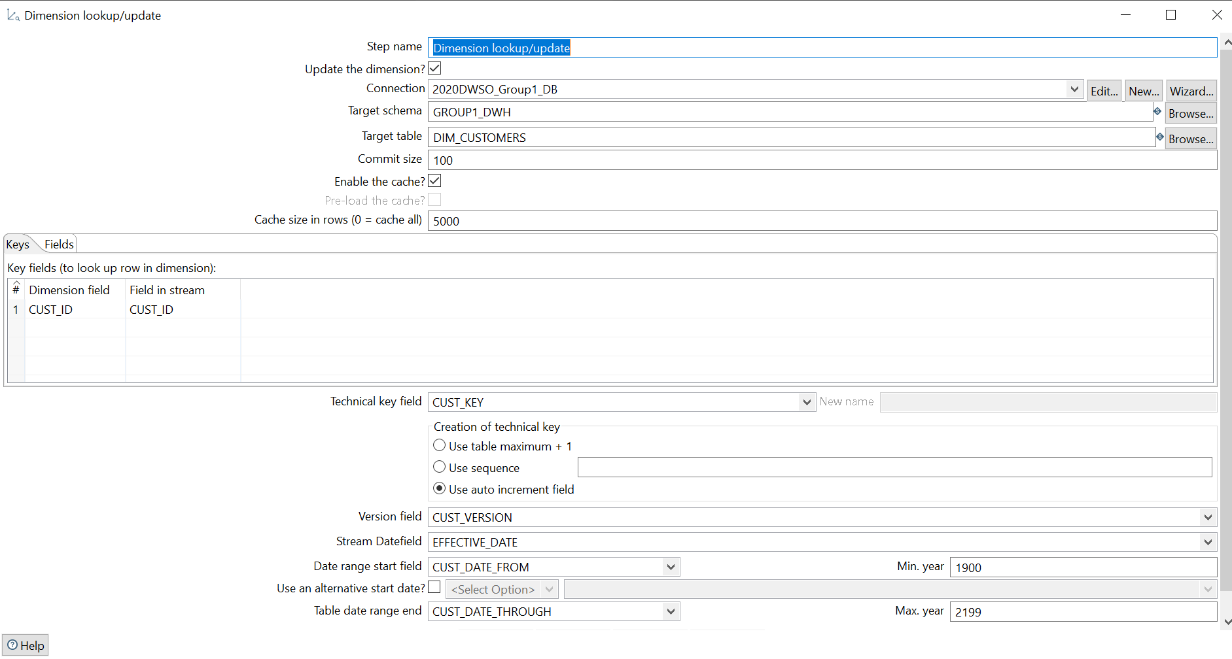

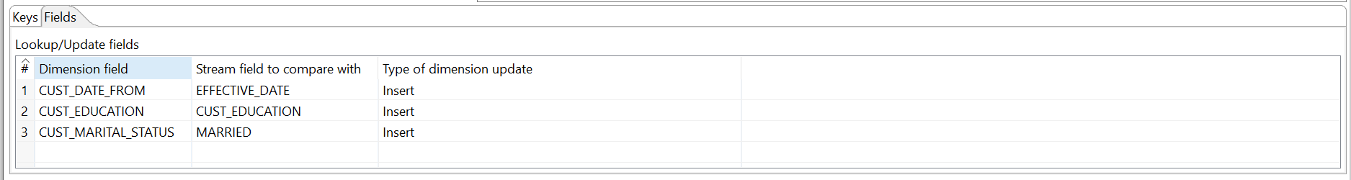

DIM_PROMOTIONS

Again, we followed the same steps as described in the previous transformations.

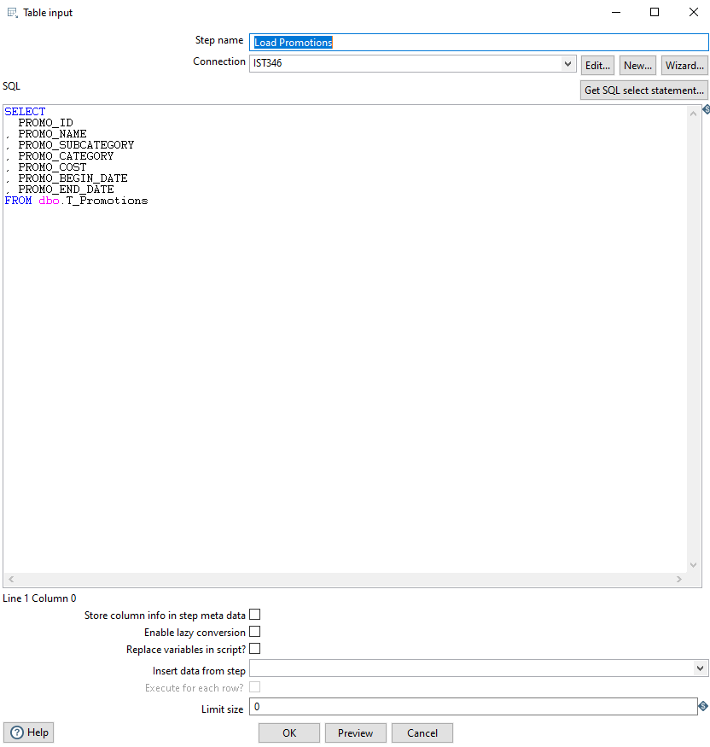

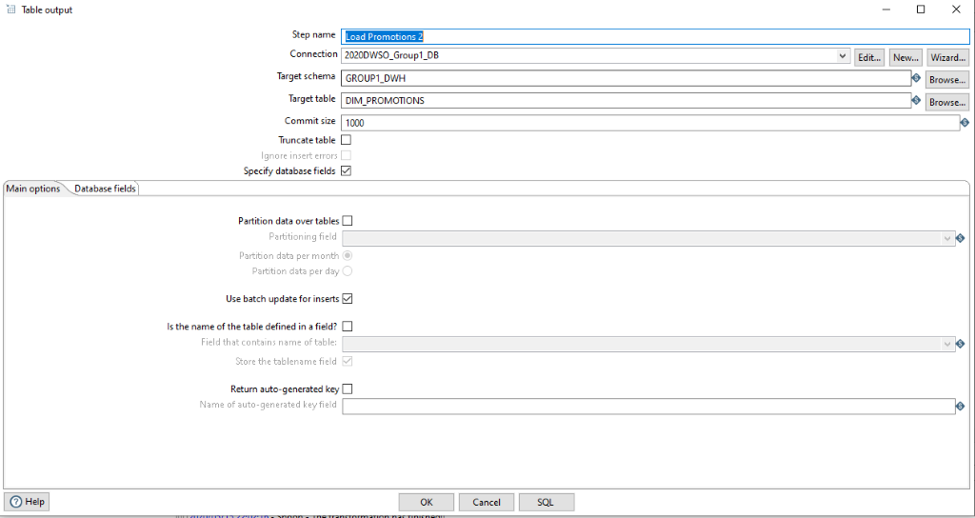

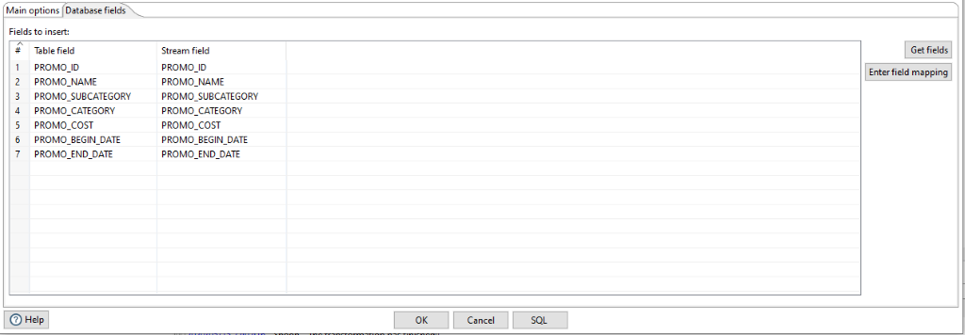

DIM_DATE:

Step 1: We generated 20 years by using generate row.

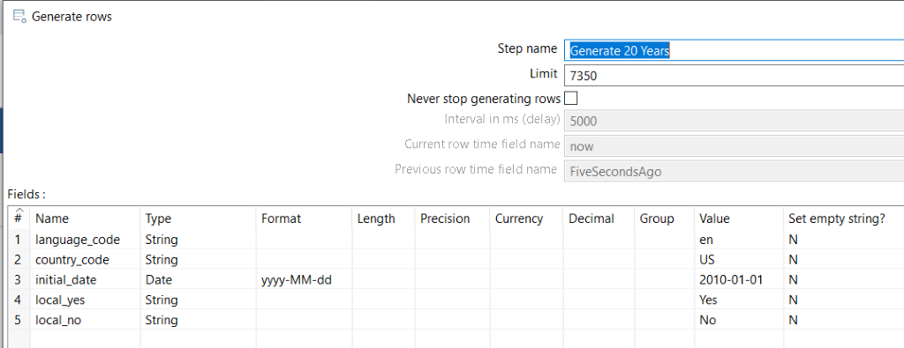

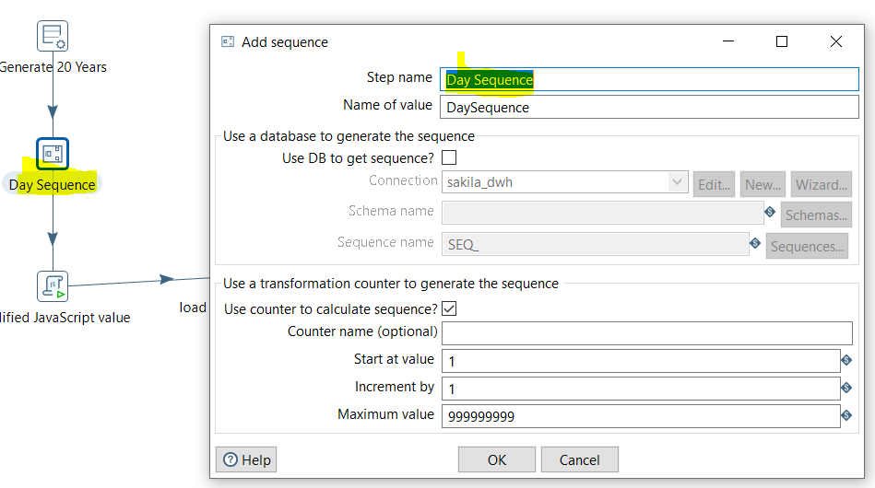

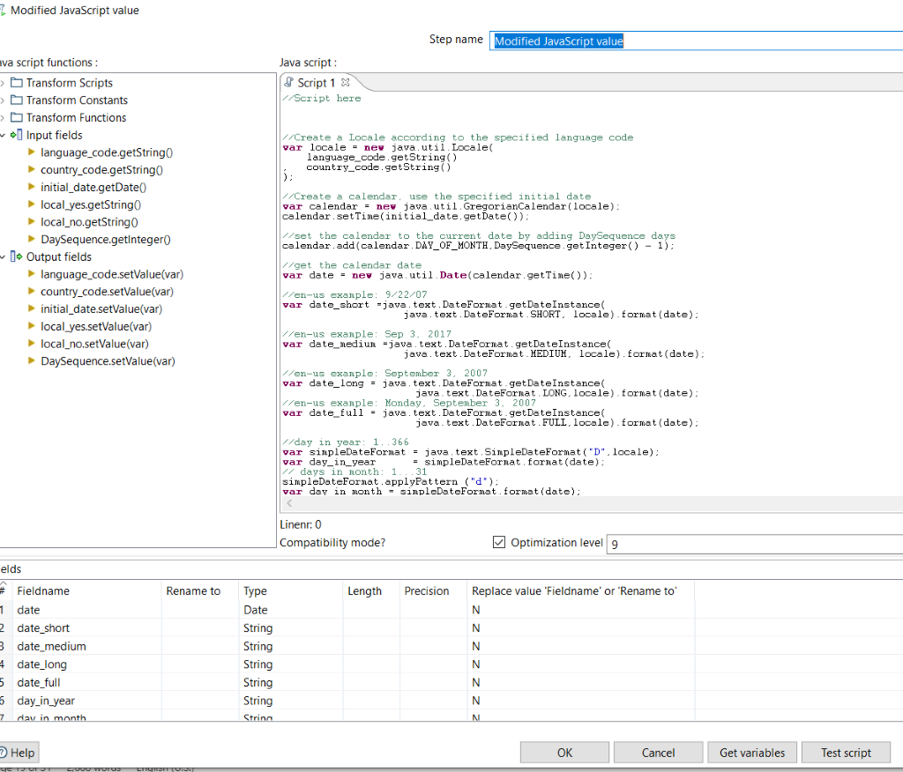

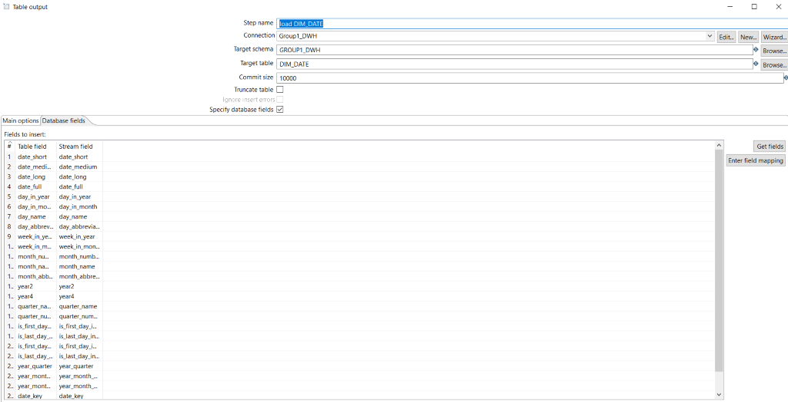

FACT_ORDERS :

We use type 2 transformation to successfully load our FACT table as shown in the steps below:

Step1: Table Input to read data from the source table:

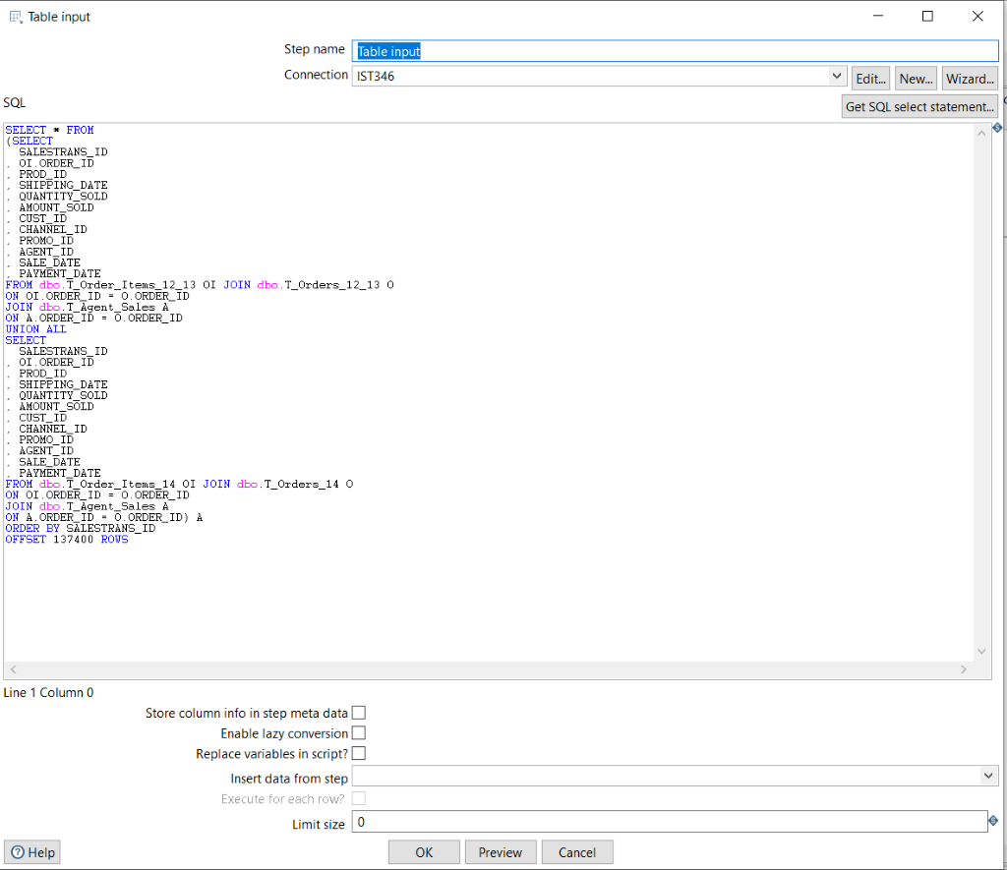

Step 2: We proceeded to mapping by using Select Value

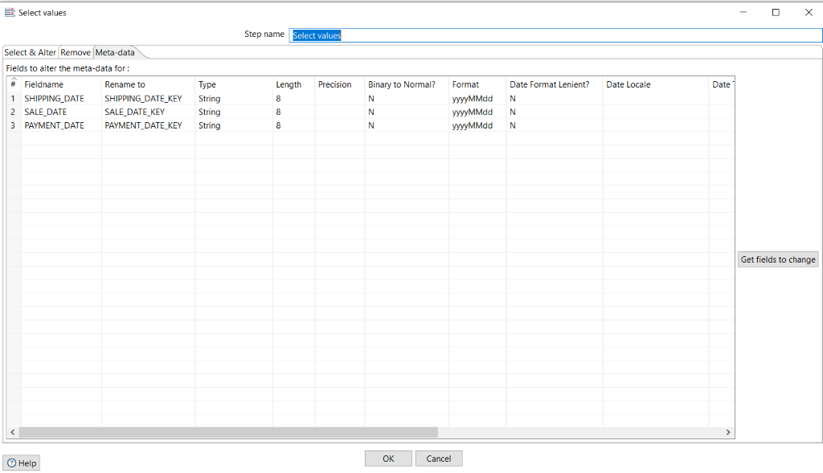

Step 3: We got Channels Key

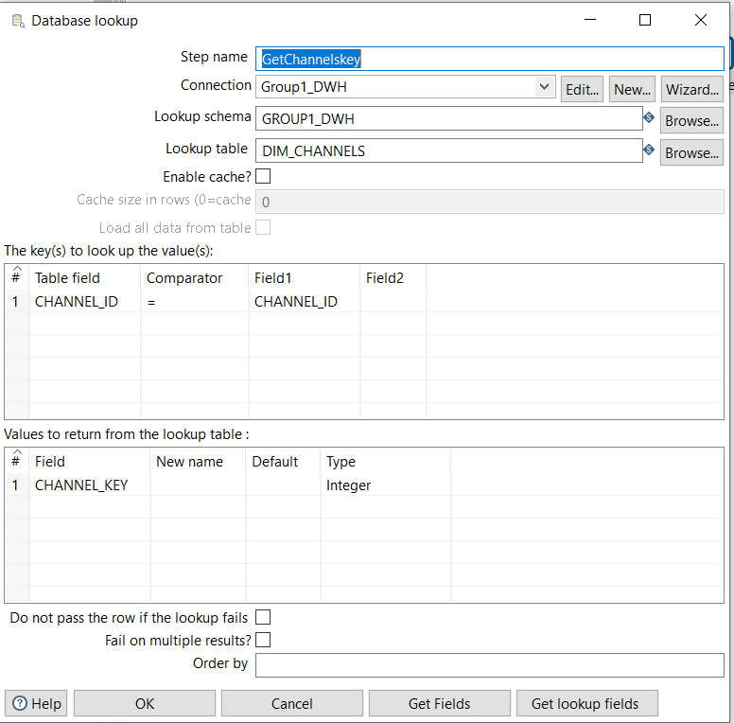

Step 4: We got the Promotion key

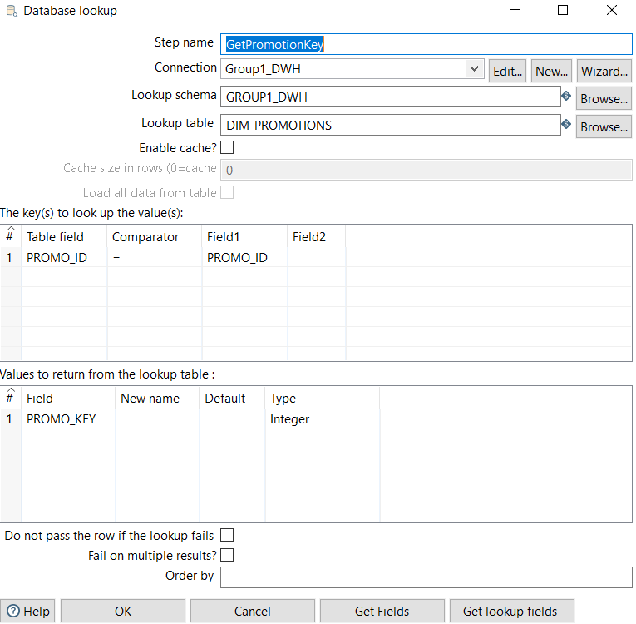

Step5: We got product key

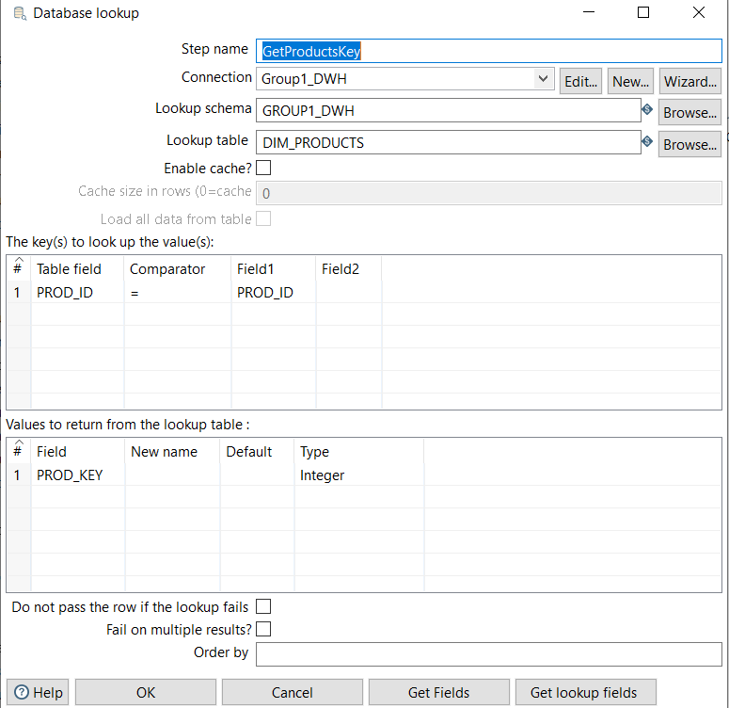

Step 6: We got Agents Key

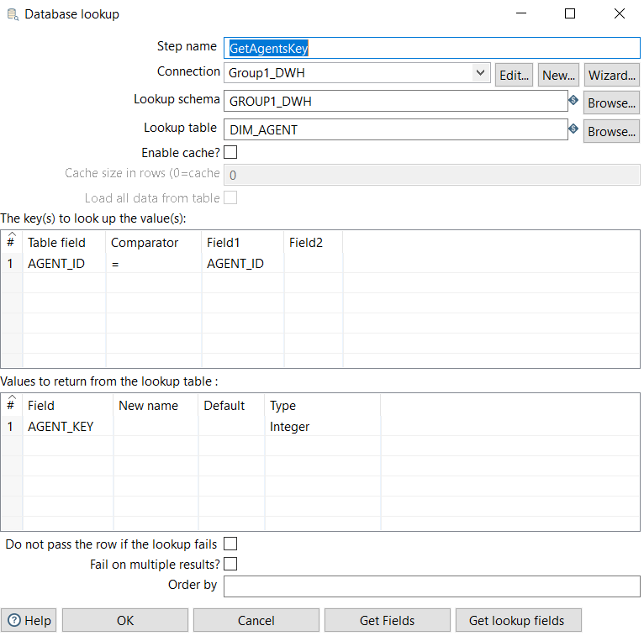

Step 7: We got Customers key

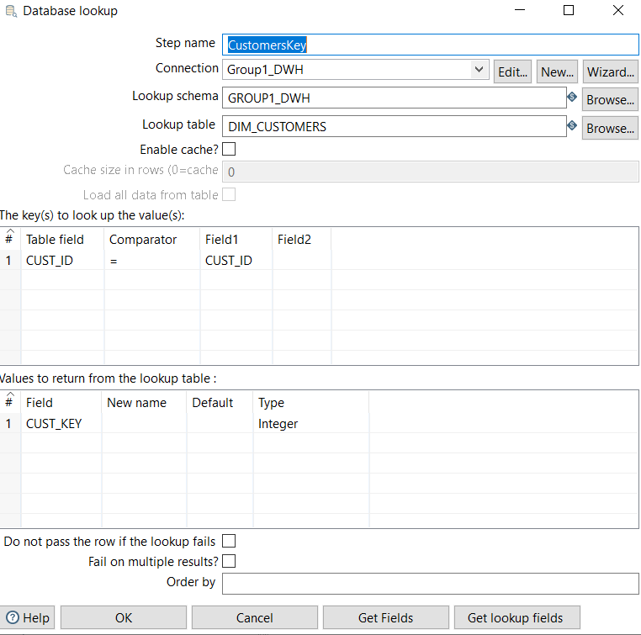

Step 8: We loaded our FACT_Orders1 using Output “Insert/Update”

